**Cryptography and 19115045**

**Network Security Lab Kunal Sachdeva**

**LAB-2 6th Sem CSE**

**1.Write a program to implement the concept of Hill Cipher.**

**Theory:**

Hill cipher is a polygraphic substitution cipher based on linear algebra.Each letter is represented by a number modulo 26. Often the simple scheme A = 0, B = 1, …, Z = 25 is used, but this is not an essential feature of the cipher. To encrypt a message, each block of n letters (considered as an n-component vector) is multiplied by an invertible n × n matrix, against modulus 26. To decrypt the message, each block is multiplied by the inverse of the matrix used for encryption.

The matrix used for encryption is the cipher key, and it should be chosen randomly from the set of invertible n × n matrices (modulo 26).

**Code:**

*#include <iostream>*

*using namespace std;*

*void getKeyMatrix(string key, int keyMatrix[][3])*

*{*

*int k = 0;*

*for (int i = 0; i < 3; i++)*

*{*

*for (int j = 0; j < 3; j++)*

*{*

*keyMatrix[i][j] = (key[k]) % 65;*

*k++;*

*}*

*}*

*}*

*void encrypt(int cipherMatrix[][1],*

*int keyMatrix[][3],*

*int messageVector[][1])*

*{*

*int x, i, j;*

*for (i = 0; i < 3; i++)*

*{*

*for (j = 0; j < 1; j++)*

*{*

*cipherMatrix[i][j] = 0;*

*for (x = 0; x < 3; x++)*

*{*

*cipherMatrix[i][j]+=keyMatrix[i][x]*messageVector[x][j];*

*}*

*cipherMatrix[i][j] = cipherMatrix[i][j] % 26;*

*}*

*}*

*}*

*void HillCipher(string message, string key)*

*{*

*int keyMatrix[3][3];*

*getKeyMatrix(key, keyMatrix);*

*int messageVector[3][1];*

*for (int i = 0; i < 3; i++)*

*messageVector[i][0] = (message[i]) % 65;*

*int cipherMatrix[3][1];*

*encrypt(cipherMatrix, keyMatrix, messageVector);*

*string CipherText;*

*for (int i = 0; i < 3; i++)*

*CipherText += cipherMatrix[i][0] + 65;*

*cout << " Ciphertext:" << CipherText;*

*}*

*int main()*

*{*

*string message = "ACT";*

*string key = "GYN KURP";*

*HillCipher(message, key);*

*return 0;*

*}*

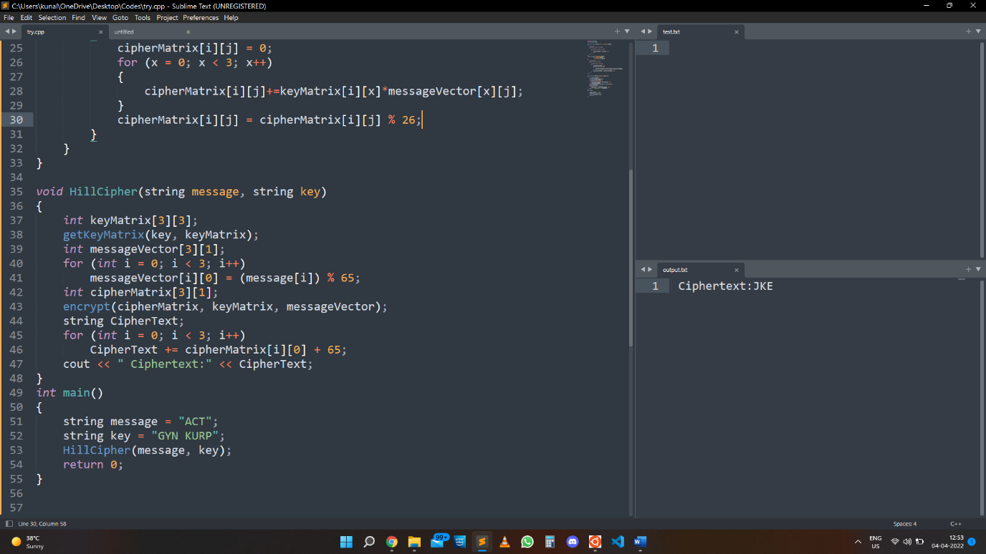**Output:**

**2. Write a program to implement the concept of vigenere cipher.**

**Theory:**

Vigenere Cipher is a method of encrypting alphabetic text. It uses a simple form of polyalphabetic substitution. A polyalphabetic cipher is any cipher based on substitution, using multiple substitution alphabets. The encryption of the original text is done using the Vigenère square or Vigenère table.

**Code:**

*#include<bits/stdc++.h>*

*using namespace std;*

*string generateKey(string str, string key)*

*{*

*int x = str.size();*

*for (int i = 0; ; i++)*

*{*

*if (x == i)*

*i = 0;*

*if (key.size() == str.size())*

*break;*

*key.push_back(key[i]);*

*}*

*return key;*

*}*

*string cipherText(string str, string key)*

*{*

*string cipher_text;*

*for (int i = 0; i < str.size(); i++)*

*{*

*char x = (str[i] + key[i]) %26;*

*x += 'A';*

*cipher_text.push_back(x);*

*}*

*return cipher_text;*

*}*

*string originalText(string cipher_text, string key)*

*{*

*string orig_text;*

*for (int i = 0 ; i < cipher_text.size(); i++)*

*{*

*char x = (cipher_text[i] - key[i] + 26) %26;*

*x += 'A';*

*orig_text.push_back(x);*

*}*

*return orig_text;*

*}*

*int main()*

*{*

*string str = "GEEKSFORGEEKS";*

*string keyword = "AYUSH";*

*string key = generateKey(str, keyword);*

*string cipher_text = cipherText(str, key);*

*cout << "Ciphertext : "<< cipher_text << "\n";*

*cout << "Original/Decrypted Text : "<< originalText(cipher_text, key);*

*return 0;*

*}*

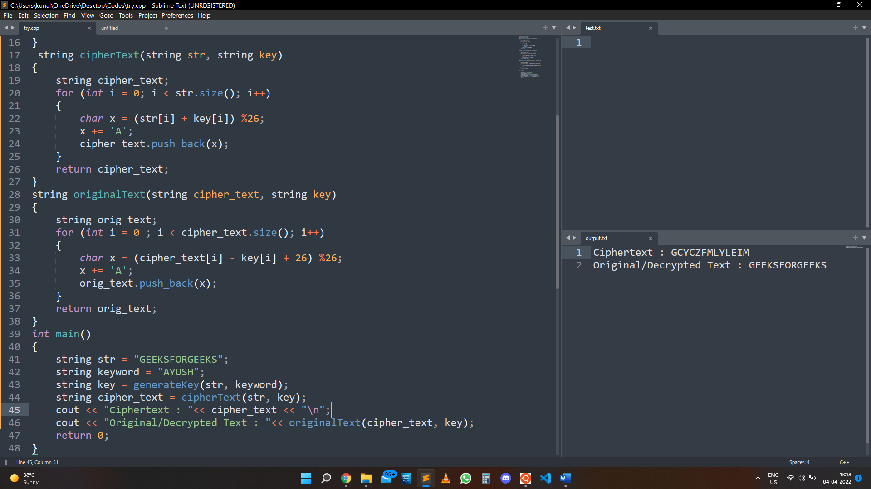**Output:**

**3. Write a program to implement the concept of Rail fence row & coloumn transformation.**

**Code:**

*#include <bits/stdc++.h>*

*using namespace std;*

*string encryptRailFence(string text, int key)*

*{*

*char rail[key][(text.length())];*

*for (int i=0; i < key; i++)*

*for (int j = 0; j < text.length(); j++)*

*rail[i][j] = '\n';*

*bool dir_down = false;*

*int row = 0, col = 0;*

*for (int i=0; i < text.length(); i++)*

*{*

*if (row == 0 || row == key-1)*

*dir_down = !dir_down;*

*rail[row][col++] = text[i];*

*dir_down?row++ : row--;*

*}*

*string result;*

*for (int i=0; i < key; i++)*

*for (int j=0; j < text.length(); j++)*

*if (rail[i][j]!='\n')*

*result.push_back(rail[i][j]);*

*return result;*

*}*

*string decryptRailFence(string cipher, int key)*

*{*

*char rail[key][cipher.length()];*

*for (int i=0; i < key; i++)*

*for (int j=0; j < cipher.length(); j++)*

*rail[i][j] = '\n';*

*bool dir_down;*

*int row = 0, col = 0;*

*for (int i=0; i < cipher.length(); i++)*

*{*

*if (row == 0)*

*dir_down = true;*

*if (row == key-1)*

*dir_down = false;*

*rail[row][col++] = '*';*

*dir_down?row++ : row--;*

*}*

*int index = 0;*

*for (int i=0; i<key; i++)*

*for (int j=0; j<cipher.length(); j++)*

*if (rail[i][j] == '*' && index<cipher.length())*

*rail[i][j] = cipher[index++];*

*string result;*

*row = 0, col = 0;*

*for (int i=0; i< cipher.length(); i++)*

*{*

*if (row == 0)*

*dir_down = true;*

*if (row == key-1)*

*dir_down = false;*

*if (rail[row][col] != '*')*

*result.push_back(rail[row][col++]);*

*dir_down?row++: row--;*

*}*

*return result;*

*}*

*int main()*

*{*

*cout << encryptRailFence("attack at once", 2) << endl;*

*cout << encryptRailFence("GeeksforGeeks ", 3) << endl;*

*cout << encryptRailFence("defend the east wall", 3) << endl;*

*cout << decryptRailFence("GsGsekfrek eoe",3) << endl;*

*cout << decryptRailFence("atc toctaka ne",2) << endl;*

*cout << decryptRailFence("dnhaweedtees alf tl",3) << endl;*

*return 0;*

*}*

**Output:** 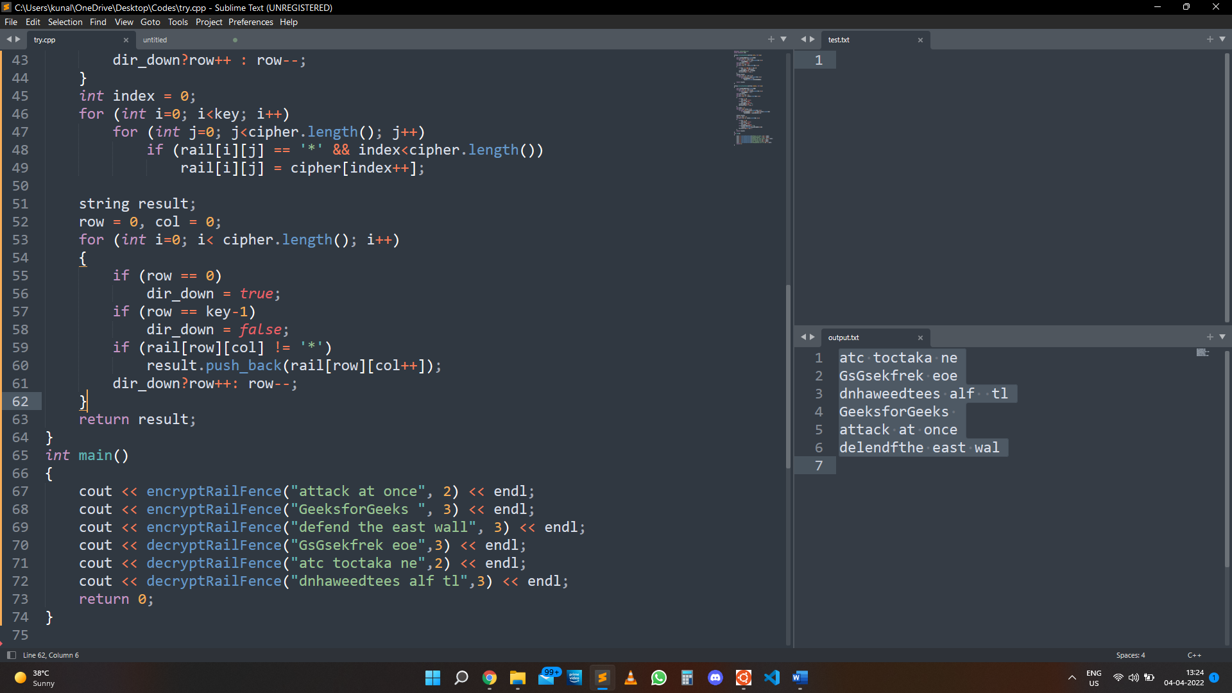

**4.Write a program to implement the concept of DES algorithm.**

**Theory:**

Data encryption standard (DES) has been found vulnerable against very powerful attacks and therefore, the popularity of DES has been found slightly on the decline.

DES is a block cipher and encrypts data in blocks of size of 64 bits each, which means 64 bits of plain text goes as the input to DES, which produces 64 bits of ciphertext. The same algorithm and key are used for encryption and decryption, with minor differences. The key length is 56 bits.

**Code:**

*#include <bits/stdc++.h>*

*using namespace std;*

*string hex2bin(string s)*

*{*

*unordered_map<char, string> mp;*

*mp['0'] = "0000";*

*mp['1'] = "0001";*

*mp['2'] = "0010";*

*mp['3'] = "0011";*

*mp['4'] = "0100";*

*mp['5'] = "0101";*

*mp['6'] = "0110";*

*mp['7'] = "0111";*

*mp['8'] = "1000";*

*mp['9'] = "1001";*

*mp['A'] = "1010";*

*mp['B'] = "1011";*

*mp['C'] = "1100";*

*mp['D'] = "1101";*

*mp['E'] = "1110";*

*mp['F'] = "1111";*

*string bin = "";*

*for (int i = 0; i < s.size(); i++) {*

*bin += mp[s[i]];*

*}*

*return bin;*

*}*

*string bin2hex(string s)*

*{*

*// binary to hexadecimal conversion*

*unordered_map<string, string> mp;*

*mp["0000"] = "0";*

*mp["0001"] = "1";*

*mp["0010"] = "2";*

*mp["0011"] = "3";*

*mp["0100"] = "4";*

*mp["0101"] = "5";*

*mp["0110"] = "6";*

*mp["0111"] = "7";*

*mp["1000"] = "8";*

*mp["1001"] = "9";*

*mp["1010"] = "A";*

*mp["1011"] = "B";*

*mp["1100"] = "C";*

*mp["1101"] = "D";*

*mp["1110"] = "E";*

*mp["1111"] = "F";*

*string hex = "";*

*for (int i = 0; i < s.length(); i += 4) {*

*string ch = "";*

*ch += s[i];*

*ch += s[i + 1];*

*ch += s[i + 2];*

*ch += s[i + 3];*

*hex += mp[ch];*

*}*

*return hex;*

*}*

*string permute(string k, int* arr, int n)*

*{*

*string per = "";*

*for (int i = 0; i < n; i++) {*

*per += k[arr[i] - 1];*

*}*

*return per;*

*}*

*string shift_left(string k, int shifts)*

*{*

*string s = "";*

*for (int i = 0; i < shifts; i++) {*

*for (int j = 1; j < 28; j++) {*

*s += k[j];*

*}*

*s += k[0];*

*k = s;*

*s = "";*

*}*

*return k;*

*}*

*string xor_(string a, string b)*

*{*

*string ans = "";*

*for (int i = 0; i < a.size(); i++) {*

*if (a[i] == b[i]) {*

*ans += "0";*

*}*

*else {*

*ans += "1";*

*}*

*}*

*return ans;*

*}*

*string encrypt(string pt, vector<string> rkb, vector<string> rk)*

*{*

*// Hexadecimal to binary*

*pt = hex2bin(pt);*

*// Initial Permutation Table*

*int initial_perm[64] = { 58, 50, 42, 34, 26, 18, 10, 2,*

*60, 52, 44, 36, 28, 20, 12, 4,*

*62, 54, 46, 38, 30, 22, 14, 6,*

*64, 56, 48, 40, 32, 24, 16, 8,*

*57, 49, 41, 33, 25, 17, 9, 1,*

*59, 51, 43, 35, 27, 19, 11, 3,*

*61, 53, 45, 37, 29, 21, 13, 5,*

*63, 55, 47, 39, 31, 23, 15, 7 };*

*// Initial Permutation*

*pt = permute(pt, initial_perm, 64);*

*cout << "After initial permutation: " << bin2hex(pt) << endl;*

*// Splitting*

*string left = pt.substr(0, 32);*

*string right = pt.substr(32, 32);*

*cout << "After splitting: L0=" << bin2hex(left)*

*<< " R0=" << bin2hex(right) << endl;*

*// Expansion D-box Table*

*int exp_d[48] = { 32, 1, 2, 3, 4, 5, 4, 5,*

*6, 7, 8, 9, 8, 9, 10, 11,*

*12, 13, 12, 13, 14, 15, 16, 17,*

*16, 17, 18, 19, 20, 21, 20, 21,*

*22, 23, 24, 25, 24, 25, 26, 27,*

*28, 29, 28, 29, 30, 31, 32, 1 };*

*// S-box Table*

*int s[8][4][16] = { { 14, 4, 13, 1, 2, 15, 11, 8, 3, 10, 6, 12, 5, 9, 0, 7,*

*0, 15, 7, 4, 14, 2, 13, 1, 10, 6, 12, 11, 9, 5, 3, 8,*

*4, 1, 14, 8, 13, 6, 2, 11, 15, 12, 9, 7, 3, 10, 5, 0,*

*15, 12, 8, 2, 4, 9, 1, 7, 5, 11, 3, 14, 10, 0, 6, 13 },*

*{ 15, 1, 8, 14, 6, 11, 3, 4, 9, 7, 2, 13, 12, 0, 5, 10,*

*3, 13, 4, 7, 15, 2, 8, 14, 12, 0, 1, 10, 6, 9, 11, 5,*

*0, 14, 7, 11, 10, 4, 13, 1, 5, 8, 12, 6, 9, 3, 2, 15,*

*13, 8, 10, 1, 3, 15, 4, 2, 11, 6, 7, 12, 0, 5, 14, 9 },*

*{ 10, 0, 9, 14, 6, 3, 15, 5, 1, 13, 12, 7, 11, 4, 2, 8,*

*13, 7, 0, 9, 3, 4, 6, 10, 2, 8, 5, 14, 12, 11, 15, 1,*

*13, 6, 4, 9, 8, 15, 3, 0, 11, 1, 2, 12, 5, 10, 14, 7,*

*1, 10, 13, 0, 6, 9, 8, 7, 4, 15, 14, 3, 11, 5, 2, 12 },*

*{ 7, 13, 14, 3, 0, 6, 9, 10, 1, 2, 8, 5, 11, 12, 4, 15,*

*13, 8, 11, 5, 6, 15, 0, 3, 4, 7, 2, 12, 1, 10, 14, 9,*

*10, 6, 9, 0, 12, 11, 7, 13, 15, 1, 3, 14, 5, 2, 8, 4,*

*3, 15, 0, 6, 10, 1, 13, 8, 9, 4, 5, 11, 12, 7, 2, 14 },*

*{ 2, 12, 4, 1, 7, 10, 11, 6, 8, 5, 3, 15, 13, 0, 14, 9,*

*14, 11, 2, 12, 4, 7, 13, 1, 5, 0, 15, 10, 3, 9, 8, 6,*

*4, 2, 1, 11, 10, 13, 7, 8, 15, 9, 12, 5, 6, 3, 0, 14,*

*11, 8, 12, 7, 1, 14, 2, 13, 6, 15, 0, 9, 10, 4, 5, 3 },*

*{ 12, 1, 10, 15, 9, 2, 6, 8, 0, 13, 3, 4, 14, 7, 5, 11,*

*10, 15, 4, 2, 7, 12, 9, 5, 6, 1, 13, 14, 0, 11, 3, 8,*

*9, 14, 15, 5, 2, 8, 12, 3, 7, 0, 4, 10, 1, 13, 11, 6,*

*4, 3, 2, 12, 9, 5, 15, 10, 11, 14, 1, 7, 6, 0, 8, 13 },*

*{ 4, 11, 2, 14, 15, 0, 8, 13, 3, 12, 9, 7, 5, 10, 6, 1,*

*13, 0, 11, 7, 4, 9, 1, 10, 14, 3, 5, 12, 2, 15, 8, 6,*

*1, 4, 11, 13, 12, 3, 7, 14, 10, 15, 6, 8, 0, 5, 9, 2,*

*6, 11, 13, 8, 1, 4, 10, 7, 9, 5, 0, 15, 14, 2, 3, 12 },*

*{ 13, 2, 8, 4, 6, 15, 11, 1, 10, 9, 3, 14, 5, 0, 12, 7,*

*1, 15, 13, 8, 10, 3, 7, 4, 12, 5, 6, 11, 0, 14, 9, 2,*

*7, 11, 4, 1, 9, 12, 14, 2, 0, 6, 10, 13, 15, 3, 5, 8,*

*2, 1, 14, 7, 4, 10, 8, 13, 15, 12, 9, 0, 3, 5, 6, 11 } };*

*// Straight Permutation Table*

*int per[32] = { 16, 7, 20, 21,*

*29, 12, 28, 17,*

*1, 15, 23, 26,*

*5, 18, 31, 10,*

*2, 8, 24, 14,*

*32, 27, 3, 9,*

*19, 13, 30, 6,*

*22, 11, 4, 25 };*

*cout << endl;*

*for (int i = 0; i < 16; i++) {*

*string right_expanded = permute(right, exp_d, 48);*

*string x = xor_(rkb[i], right_expanded);*

*string op = "";*

*for (int i = 0; i < 8; i++) {*

*int row = 2 * int(x[i * 6] - '0') + int(x[i * 6 + 5] - '0');*

*int col = 8 * int(x[i * 6 + 1] - '0') + 4 * int(x[i * 6 + 2] - '0') + 2 * int(x[i * 6 + 3] - '0') + int(x[i * 6 + 4] - '0');*

*int val = s[i][row][col];*

*op += char(val / 8 + '0');*

*val = val % 8;*

*op += char(val / 4 + '0');*

*val = val % 4;*

*op += char(val / 2 + '0');*

*val = val % 2;*

*op += char(val + '0');*

*}*

*op = permute(op, per, 32);*

*x = xor_(op, left);*

*left = x;*

*if (i != 15) {*

*swap(left, right);*

*}*

*cout << "Round " << i + 1 << " " << bin2hex(left) << " "*

*<< bin2hex(right) << " " << rk[i] << endl;*

*}*

*string combine = left + right;*

*int final_perm[64] = { 40, 8, 48, 16, 56, 24, 64, 32,*

*39, 7, 47, 15, 55, 23, 63, 31,*

*38, 6, 46, 14, 54, 22, 62, 30,*

*37, 5, 45, 13, 53, 21, 61, 29,*

*36, 4, 44, 12, 52, 20, 60, 28,*

*35, 3, 43, 11, 51, 19, 59, 27,*

*34, 2, 42, 10, 50, 18, 58, 26,*

*33, 1, 41, 9, 49, 17, 57, 25 };*

*string cipher = bin2hex(permute(combine, final_perm, 64));*

*return cipher;*

*}*

*int main()*

*{*

*string pt, key;*

*/*cout<<"Enter plain text(in hexadecimal): ";*

*cin>>pt;*

*cout<<"Enter key(in hexadecimal): ";*

*cin>>key;*/*

*pt = "123456ABCD132536";*

*key = "AABB09182736CCDD";*

*key = hex2bin(key);*

*// Parity bit drop table*

*int keyp[56] = { 57, 49, 41, 33, 25, 17, 9,*

*1, 58, 50, 42, 34, 26, 18,*

*10, 2, 59, 51, 43, 35, 27,*

*19, 11, 3, 60, 52, 44, 36,*

*63, 55, 47, 39, 31, 23, 15,*

*7, 62, 54, 46, 38, 30, 22,*

*14, 6, 61, 53, 45, 37, 29,*

*21, 13, 5, 28, 20, 12, 4 };*

*key = permute(key, keyp, 56); // key without parity*

*int shift_table[16] = { 1, 1, 2, 2,*

*2, 2, 2, 2,*

*1, 2, 2, 2,*

*2, 2, 2, 1 };*

*int key_comp[48] = { 14, 17, 11, 24, 1, 5,*

*3, 28, 15, 6, 21, 10,*

*23, 19, 12, 4, 26, 8,*

*16, 7, 27, 20, 13, 2,*

*41, 52, 31, 37, 47, 55,*

*30, 40, 51, 45, 33, 48,*

*44, 49, 39, 56, 34, 53,*

*46, 42, 50, 36, 29, 32 };*

*string left = key.substr(0, 28);*

*string right = key.substr(28, 28);*

*vector<string> rkb; // rkb for RoundKeys in binary*

*vector<string> rk; // rk for RoundKeys in hexadecimal*

*for (int i = 0; i < 16; i++) {*

*left = shift_left(left, shift_table[i]);*

*right = shift_left(right, shift_table[i]);*

*string combine = left + right;*

*string RoundKey = permute(combine, key_comp, 48);*

*rkb.push_back(RoundKey);*

*rk.push_back(bin2hex(RoundKey));*

*}*

*cout << "Encryption:\n\n";*

*string cipher = encrypt(pt, rkb, rk);*

*cout << "\nCipher Text: " << cipher << endl;*

*cout << "\nDecryption\n\n";*

*reverse(rkb.begin(), rkb.end());*

*reverse(rk.begin(), rk.end());*

*string text = encrypt(cipher, rkb, rk);*

*cout << "\nPlain Text: " << text << endl;*

*}*

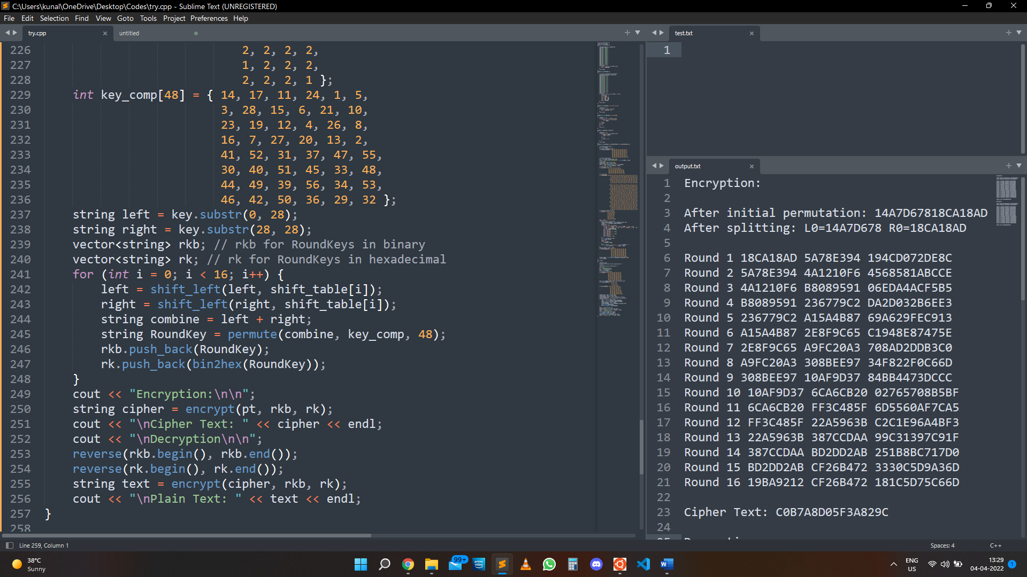**Output:**

